Neighborhood and Community Services

Southgate Community Day 2019 Talent Contest
Audition Location: 12125 Pinecrest Road, Reston, VA 20191

Please call (703)324-8730 or email Richard.Cabellos@fairfaxcounty.gov
for more information.
If you need to fax your application please do so to (703)324-3976
AUDITION REGISTRATION

Participant Name(s): _____________________________________________________________

School(s): _________________________ Grade(s): _________ Age(s):_______

Cell/Phone: __________________Email:________________________________

Brief Description of Act: __________________________________________________

Please call (703)324-8730 or email Richard.Cabellos@fairfaxcounty.gov
for more information.
If you need to fax your application please do so to (703)324-3976
Please call (703)324-8730 or email Richard.Cabellos@fairfaxcounty.gov
for more information.
If you need to fax your application please do so to (703)324-3976
Please call (703)324-8730 or email Richard.Cabellos@fairfaxcounty.gov
for more information.
If you need to fax your application please do so to (703)324-3976

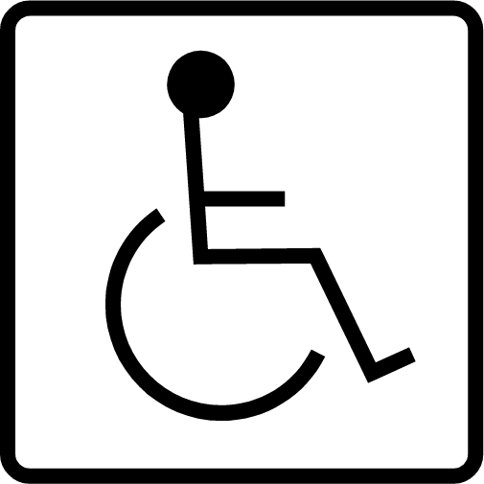
Fairfax County is committed to nondiscrimination on the basis of disability in all county programs, services and activities.
Reasonable accommodations will be provided upon request. For more information, call 703-324-4600, TTY 711.
September 2019
www.fairfaxcounty.gov/ncs
A Fairfax County, Va., publication
Please call (703) 860-0676 or email christine.hodgson@fairfaxcounty.gov with questions.

TALENT CONTEST GUIDELINES
- Participants must be in 1st-12th grade
- Participants must be available to compete on October 19th if they advance to the next round.
- Participants MUST audition with song/act that will be used on October 19th
- Any cussing, explicit lyrics, name calling, gang affiliation, violent gestures in participant’s act will result in IMMEDIATE DISQUALIFICATION.

COMMUNITY CENTER CODE OF CONDUCT
Community Center participants are expected to uphold the six pillars of “Character Counts,” which include: Trustworthiness, Respect, Responsibility, Fairness, Caring, and Citizenship. Behavior contrary to these principles will result in suspension or expulsion from the community center and in some cases prosecution.

- No drugs, alcohol or weapons are allowed inside or on the grounds of the community center.
- No smoking is allowed inside or on the grounds of the community center.
- Abusive and insulting language will not be tolerated.
- Fighting, theft, and vandalism are not allowed.
- Physical or sexual assault, battery, or improper touching will result in suspension and/or may be reported to the authorities.
- Loitering is not allowed on community center property.

PARTICIPANT AGREEMENT

I have read and understand the above participation guidelines and by my signature agree to its terms.

Participant Signature: ____________________________ Date

Parent/Guardian Signature : Date

