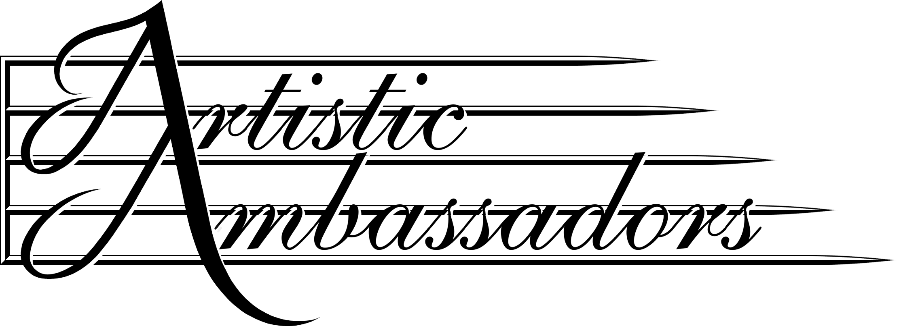
SOUTH LAKES HIGH SCHOOL
NASHVILLE, TN
APRIL 16, 2015 – APRIL 19, 2015

INDIVIDUAL PASSENGER CONTACT INFORMATION FORM
Please print and complete this form and return it to your group tour leader.

NAME: _____________________________________________________ AGE: ____________

STREET ADDRESS: __________________________________________________________________

CITY: ______________________________________ STATE: ________ ZIP: ____________

HOME TEL: ________________________________ WORK TEL: _____________________________

CITIZENSHIP: USA OTHER: _____________________________________________

TRAVEL INSURANCE APPLICATION NEEDED: YES NO

===================================================================

NAME OF RELATIVE OR FRIEND NOT TRAVELING WITH YOU:

_________________________________________________________________________________________

AREA CODE AND TELEPHONE: EMAIL:

________________________________________ _________________________________________

===================================================================
NOTICE AND CONTRACT OF RELEASE AND ASSUMPTION OF RISK

Classic Travel And Tours LLC/Artistic Ambassadors acts as an agent for suppliers in selling travel and/or arranging services that are not directly supplied by Classic Travel And Tours LLC/Artistic Ambassadors. Classic Travel And Tours LLC/Artistic Ambassadors shall not be responsible for breach of contract, errors or omissions on the part of suppliers. This agency will not be responsible for injuries, damages, or losses that result from criminal acts, terrorism, strikes, mechanical or construction failures, weather, local laws or health conditions and/or any abnormal situations outside of Classic Travel And Tours LLC/Artistic Ambassadors’ control. It is the traveler’s responsibility to assume the risks of travel and for passport, vaccination, visa, and entry requirements. Optional travel insurance is available and is recommended. As consideration of and as part of the payment for the right to participate in this tour, I agree to hold Classic Travel And Tours LLC/Artistic Ambassadors harmless and to release it from liability as well as its agents, employees, officers, directors, and affiliated companies or subcontractors for any and all actions, debts, suits, claims, and demands of any kind in connection with my participation in this tour either now or in the future. This agreement serves as a release and assumption of risk for myself, my family, and my heirs. I have read and understand this notice and contract.

SIGNATURE: ___________________________________________ DATE: _______________________

SIGNATURE: ___________________________________________ DATE: _______________________
(Parent/s or Legal Guardian/s if traveler is under eighteen (18) years)

