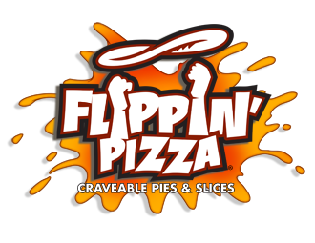
South Lakes Shopping Center
571-323-7820

SLHS Chorus Restaurant Night
Monday, Nov 25th
2:30p -10:00p

Give this flyer to the cashier and Flippin’ will donate 50% of your
total purchase to SLHS Chorus

