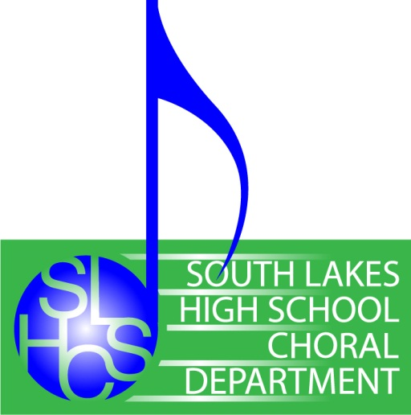
Parents for Choral Arts (PCA)

a 501(c)(3) Tax Exempt Organization

c/o SLHS Choral Department
11400 South Lakes Drive
Reston, VA 20191
www.southlakeschorus.org

South Lakes High School’s Chorus Boosters

The South Lakes Choral Program is comprised of 175 talented and enthusiastic vocal performers. Every year we seek additional funding to enable all these students to participate in valuable educational opportunities. It is a fact that the expenses of any Fairfax County Public High School Choral Program exceed the annual subsidy provided. Parent booster organizations, like Parents for Choral Arts (PCA) are created to fill this gap by providing organized fundraising and volunteer support to the Choral director.
Donations made to the Parents for Choral Arts (PCA), the SLHS Chorus parent booster organization, will be used to: pay specialized clinicians to train our singers; subsidize uniform fees; reduce student share of expenses when traveling to competitions and other music events; provide scholarship funds for students in financial need; and will purchase additional materials to expand our choral music library & other curricular materials.
The South Lakes High School Chorus has represented the Reston Community with pride and musical excellence over the last nine years. Ensembles have been selected to be featured performers for the Virginia Music Educators In-Service Conference, for WNBA and NBA Games, Corporate Galas, Community Events, and at universities throughout the Eastern Coast. Ensembles consistently earn Superior ratings and rank amongst the top 5% in the country at county, state and national adjudications.
The Virginia Music Educators Association has named South Lakes High School’s Music Department a ‘Blue Ribbon School’ since 2009 for earning Superior ratings. The Choral Department is the proud recipient of the 2011 American Association for People with Disabilities (AAPD) Inclusion & Diversity in the Arts Award.
Our specific fundraising needs this year are: to help all of our choral students travel to New York, NY in April, 2014 to workshop with Broadway Singers & Actors, and subsidize costs for new Choral Uniforms.
If you want to support our work with a tax deductible donation, please use tear off form below or donate on-line by going to http://southlakeschorus.org/fundraising/ads-and-tickets/. Select “Additional Donation” and input $ amount you wish to donate. Tax ID: 26-3487105

======================== (Mail In Donation Form: Cut Here) ========================

Enclosed is my (tax deductible*) contribution for $ _____________. ( CASH / CHECK )
(*For your tax records, a receipt will be sent for any identifiable donation of $25 or more.) Tax ID: 26-3487105

Receipt Address: ___________________________________
Name: _____________________________________ ___________________________________

Please make checks payable to SLHS Parents for Choral Arts (PCA) and mail donation to:
SLHS Choral Department, 11400 South Lakes Drive, Reston, VA 20191
Thank you for your support!

